**CSCE 5300 Project**

**The Predictive Analysis of Crop Recommendation using HADOOP and BIG DATA**

**Submitted By - Group 8**

1.Aditya Naga Venkatakrishna Chaitanya Kandregula

2.Anirudha Kulakarni Karanam

3.Mahaboob Ali Chisti Shaik

4.Surya Vamsi Chintapalli

**1. Introduction:**

Agriculture is an important source of economic development. It is the backbone of the world’s economy and provides food, fibre and other essential resources to sustain life. Agriculture is still a well-known occupation in many countries like India, USA, China, Brazil and etc.

The crop yield mainly depends on weather conditions i.e. Temperature and rainfall. Today youngsters are very much interested in farming system because the current status in Indian agriculture is very satisfactory and using latest technologies to make this agriculture more prestigious as the world’s economy is increasing year by year and the need of food is becoming more valuable.

In this project we gather and analyse various types of data related to agriculture such as temperature, rainfall data in selected regions. The aim of this datasets is to provide farmers with valuable insights that can help them improve the yield and quality of their crops.

By collecting temperature and rainfall datasets, for example farmers can determine the best time to cultivate agriculture so that the farmers can get a good profit income.

**2. Goals & Objectives:**

**2.1. Motivation:**

The main motivation of this project is to predict the crop yield and whether the crops are grown in a good geological condition. In the world, the population has increased the productivity of the food also need to be good and sufficient for future generations since the world is growing faster in terms of technology and industries. Due to this a lot of gases and chemicals are released into the global environment. This is impacting the climatic conditions and there is a sudden change in the weather seasons. This will impact the production of food.

In today’s world to identify the real problem we are predicting which conditions are good to cultivate. At the same time, we can also identify times when the production is less. By these abnormal changes, we can take preventive measures to safeguard everyone's hunger.

**2.2. Significance:**

Due to weather changes, farmers do not know when to sow or harvest it is becoming difficult these days. Prediction of temperature and monthly rainfall data helps to better understand what best times for sowing and harvesting and find out if a crop can grow in a suitable environment or not. This prediction could also help scientists to find the root cause or solution for low yield in crops.

**2.3. Objectives**

The main goal is to collect data of weather, rainfall & soil (in terms of soil nutrients like nitrogen, potassium, phosphorus etc. & their PH values) properties of different regions and analyze data. Once the data is collected, we will process the data and run through spark’s regression models to get future predictions of required data for the crop yield and that predicted values are used to see if all the conditions were suitable for its growth. This will help to predict the crop yield for upcoming days.

For example, we are considering the wheat crop, for the growth of wheat the ideal conditions are as follows:

* Nutrients in the soil viz. Nitrogen, phosphorus, and potassium should be in doses of 50, 25, and 12 kg per acre.
* Temperature must be between 10-15 degrees centigrade at the time of sowing
* Temperature must be between 21-26 degrees centigrade at the time of harvesting
* Wheat productivity is good if the rainfall is between 75 and 100 cm.

Based on these ideal conditions and the predicted data of rainfall & weather and changes in soil properties we can determine which time in the future is better to grow wheat.

**2.4. Features:**

1.**Temperature:** As mentioned in the objectives, the temperature could affect the growth of the crop, so this could be measured and used as a feature.

2.**Rainfall:** The amount of rainfall could be measured and used as a feature, as this is important for determining the suitability of the environment for the crop.

3.**Location:** The location where the crop is being grown could also be considered as a feature, as different regions may have different ideal conditions for crop growth.

4.**Recommendation Dataset :** At last, we are obtaining the values of temperature and rainfall We are comparing them with the Crop Recommendation Dataset.

5.**Year** : We have taken this to collect annual average Temperature and Rainfall values.

6.**T average:** By using Temperature average feature we are obtaining month wise average Data.

**7.SUBDIVISION:** In this feature we are describing the area or a particular Region**.**

**8.Annual :** By using this we can collect all month's data by averaging the values.

**9.Seasonal Average :** By using this we are able to extract the average Rainfall for each quarter.

**Technical Workflow**

Load data sets into hdfs

Required data is filtered from Solr

Data from Solr is stored into HDFS

Proccessed data is loaded into Hive tables

Using Spark to predict data

Visulalize results

**3. Related Work**

Rishi Gupta et al. [21] studied several regions and developed a crop recommendation model using temperature, rainfall, soil, seed, crop yield, humidity, and wind speed data. The data is cleaned using the pandas package before being given into MapReduce for processing. The data is processed in key value pairs in the map function, with the key being region, year, season, and crop, and the value being production per area. The reduction function computes the production per area. MapReduce will produce a super dataset that aggregates all datasets. Lastly, the authors built the recommendation model using K-means clustering.

Monisha et al. [21] published a report comparing various machine learning techniques used in crop yield prediction research. The data is divided into two parts: 80 percent is used to test the model and 20 percent is used to train the model. Once the data has been prepared, it is used to train several models such as linear regression, KNN, Deep learning, XG Boost, K-means clustering based model, random forest classifier, logistic regression, and neural network in order to assess their performance in forecasting the data. According to their findings, the random forest classifier predicts that data with 99% accuracy, followed by the KNN model with 95% accuracy and XG Boost with 94% accuracy.

This paper was written by Shruthi U, Nagaveni V and Sunil G L in the year 2022. The title of this project is review on the prediction of crop yield using Machine Learning Techniques. So, the aim of this project is to predict the crop yield using the soil properties and rainfall data. This paper has taken samples of different crops from different districts in India. The parameters vary for each crop, but the most used parameters are Rainfall, Soil, Temperature, Area, Production and Yield. In this paper they used supervised and unsupervised machine learning algorithms. Classification and Regression are the techniques used in supervised algorithm and Clustering and association rule are the techniques used in unsupervised algorithm. The result was given in the form of accuracy for each crop. Better accuracy was obtained for the crops which used clustering algorithm.

This paper is written by Swati Vashisht, Praveen K, Munesh C T in the year 2022. The title of this project is Improvised Extreme Learning Machine for Crop Yield Prediction. This article discusses the application of machine learning in crop yield prediction. They have used an extreme learning machine that utilizes Kalman Filter Algorithm for data pre-processing, Linear Discriminant Analysis for feature extraction, and an improved version of Extreme Linear Machine for crop yield prediction. They have only taken the data used to predict the yield of rice crop based on the parameter’s geography, season and area of cultivation. Here the accuracy, recall, precision and estimated f1 score are used to evaluate the performance. According to their finding Extreme Learning Machine (ELM) has obtained a higher accuracy i.e., 98.83% than the other CNN & Particle Swarm Optimization with 98.2%, LeNet 98.64% and Deep CNN 97.2% models.

Crop Recommendation System by Atharva Ingle

The crop prediction dataset is used in this notebook to recommend crops. The data includes rainfall, pH, and the presence of nitrogen, phosphorus, and potassium in the soil. In this project, pandas sed to generate the data frame and analyze the data, while the sklearn package is utilized to train and forecast models. Matplotlib is used to visualize data. The author created different models by splitting the data in 80/20 for training and testing, and utilized the Random Forest model, which had the highest accuracy for final prediction.

India Crop Production Analysis by Vasu Adireddy

This dataset is focused on the crop “Arecanut” from the Andaman and Nicobar Island in different monsoons. The data includes Production, Yield, Area, Season, State, District, Crop, Crop year. In this project pandas are used for data pre-processing and NumPy is used for linear algebra while matplotlib is used to visualize the data. This code helps to find in which monsoon the crop grows better.

**Reference Project:Crop Yield Prediction. (n.d.). Kaggle.com. Retrieved April 2, 2023, from**

Since global economy depends heavily on the agricultural sector. Understanding global agricultural output is essential to addressing issues of food security and minimizing the effects of climate change as the human population continues to grow.

Predicting crop yields is a significant agricultural issue. For making judgments regarding agricultural risk management and generating forecasts for the future, it is vital to understand that agricultural productivity is primarily influenced by weather conditions (rain, temperature, etc.), pesticides, and reliable information about past crop yield. The fundamental components that keep us alive are identical. We consume large amounts of rice, corn, wheat, and other basic crops. The analysis and forecasting of top 10 most consumed yields all over the world is established by applying machine learning techniques. It consists of 10 most consumed crops. It is a regression problem.

1.**Gathering and Cleaning Data.**

2.**Drop unwanted columns**.

3. **Climate Data: Rainfall**

The climatic factors include rainfall and temperature. They are abiotic components, including pesticides and soil, of the environmental factors that influence plant growth and development.

Rainfall has a dramatic effect on agriculture. For this project rainfall per year information was gathered from World Data Bank.

By using Pandas we can convert average_rain_fall_mm_per_year from object to float.

Next, By dropping any empty rows from dataset and merge yield data frame with rain data frame by year and area columns.

Merge Yield Data frame with rain Data frame by year and area columns

**Pesticides Data:**

Pesticides used for each item and country was also collected from FAO database.

**Data Pre-processing**

It is a technique that is used to convert raw data into a clean data set. In other words, whenever the data is gathered from different sources it is collected in raw format which is not feasible for analysis.

**Encoding Categorical Variables:**

The data frame contains two categorical columns, which are variables that have label values rather than numeric values. The range of available values is frequently constrained to a predetermined set, like in this case, the values for the items and nations. Several machine learning algorithms are unable to directly act on label data. They demand that all input and output variables be numbers.

Thus, categorical data must be transformed into numerical data. One hot encoding method involves transforming categorical information into a format that may be given to ML algorithms to help them perform better at prediction. These two columns will be converted to a one-hot numeric array for that purpose using the One-Hot Encoding method. The categorical value represents the numerical value of the entry in the dataset. This encoding will create a binary column for each category and returns a matrix with the results.

**Scaling Features:**

Taking a look at the dataset above, it contains features highly varying in magnitudes, units and range. The features with high magnitudes will weigh in a lot more in the distance calculations than features with low magnitudes.

To supress this effect, we need to bring all features to the same level of magnitudes. This can be acheived by scaling.

**Training Data:**

The dataset will be split to two datasets, the training dataset and test dataset. The data is usually tend to be split inequality because training the model usually requires as much data-points as possible.The common splits are 70/30 or 80/20 for train/test.

The training dataset is the intial dataset used to train ML algorithm to learn and produce right predictions. (70% of dataset is training dataset)

The test dataset, however, is used to assess how well ML algorithm is trained with the training dataset. You can’t simply reuse the training dataset in the testing stage because ML algorithm will already “know” the expected output, which defeats the purpose of testing the algorithm. (30% of dataset is testing dataset)

The evaluation metric is set based on **R^2 (coefficient of determination)** regression score function, that will represents the proportion of the variance for items (crops) in the regression model. **R^2** score shows how well terms (data points) fit a curve or line.

**R^2** is a statistical measure between 0 and 1 which calculates how similar a regression line is to the data it’s fitted to. If it’s a 1, the model 100% predicts the data variance; if it’s a 0, the model predicts none of the variance.

From results viewd above, **Decision Tree Regressor** has the highest R^2 score 0f **96%**, **GradientBoostingRegressor** comes second.

I'll also calculate **Adjusted R^2** also indicates how well terms fit a curve or line, but adjusts for the number of terms in a model. If you add more and more useless variables to a model, adjusted r-squared will decrease. If you add more useful variables, adjusted r-squared will increase. Adjusted R2 will always be less than or equal to R2.

The crop being potatoes has the highest importance in the decision making for the model, where it's the highest crops in the dataset. Cassava too, then as expected we see the effect of pesticides, where its the third most important feature, and then if the crop is sweet potatoes, we see some of the highest crops in features importance in dataset.

If the crop is grown in India, makes sense since India has the largest crops sum in the dataset. Then comes rainfall and temperature. The first assumption about these features were correct, where they all significantly impact the expected crops yield in the model.At last, we are using matplotlib to display the Graphical values.

**K. Sharma and A. S. Rajawat,** "Crop Yield Prediction using Hybrid Deep Learning Algorithm for Smart Agriculture," 2022 Second International Conference on Artificial Intelligence and Smart Energy (ICAIS), Coimbatore, India, 2022, pp. 330-335, doi: 10.1109/ICAIS53314.2022.9743001.

Using IoT and cloud computing technology to enhance agricultural processes and boost yield production constitutes smart agriculture. These technologies can be used to automate irrigation, control weather, monitor crops and environmental conditions, and give precise agricultural planning.

Crop production prediction is one of the main uses of smart agriculture. This can be done by combining data from sensors, RFID, GPRS, 3G wireless internet, and other sources to create data that is processed and analyzed by a cloud-based server.

A layered method that includes a front-end layer with sensors and cameras to monitor crop conditions, a gateway layer that delivers data to the cloud, and a back-end layer that enables end-user access to data can be used to execute smart agriculture.

To assess the data gathered from multiple sources and provide insights into crop conditions, including physical and chemical demands, illnesses, and acceptable pesticides and fungicides, machine learning techniques like Deep Learning and Multilayer Perceptron can be utilized.

Installing infrared camera sensors that can distinguish between intruders and farmers on the ground can help farmers safeguard their crops from intruders and pests. Moreover, crop development factors during the harvesting stage, including nutrient data, plant weight, and humidity levels, can be monitored using RFID technology.

By providing real-time information on crop conditions, weather, and other variables that affect yield production, smart agriculture can, in general, assist farmers in producing yields that are successful under a wide range of geographical, environmental, land, and plant variables.

The system for collecting and analyzing agricultural data in real-time to improve crop yield forecast is discussed in the text. The information gathering layer, transportation layer, and application layer are the three levels that make up the system. The information-gathering layer gathers physical data from agricultural sensors and converts it into processable digital data. The sensor layer processes the agricultural data that was collected and summarized by the transportation layer, and the application layer analyses and processes the data to improve crop yield forecast.

For feature extraction and picture retrieval tasks, the system suggests a hybrid deep learning strategy employing a backpropagation neural network and a convolutional neural network. The authors suggest employing a deep CNN model that has already been trained to understand features and show that the suggested strategy yields higher performance than traditional handcrafted features.

**Big Data and AI Revolution in Precision Agriculture**

To achieve sustainable agriculture production, advanced technologies such as blockchain, IoT, and AI need to be integrated into the agriculture sector. By embracing data-driven agriculture with these technologies, we can take the most promising approach to address current and future challenges. By collecting enormous amounts of data from farms and thus utilize it in agricultural decision-making. The use of IoT technology in agriculture allows for data collection throughout the various stages of production. As a result, it would be beneficial to analyze the large amounts of data generated during farming, processing, logistics, and marketing using big data analytics.

To acquire field data accurately, IoT devices, remote sensing, and other sensor networks are deployed. The data collected from these networks on soil, crops, weather, and the surrounding environment is stored on either local or cloud storage. ML-based big data algorithms are then used to extract important information from this data and aid farmers in making informed decisions. Based on the recommendations provided by the decision-making system, advanced machinery equipped with an intelligent control system physically executes the required actions. This process continues systematically until the harvesting stage. Software tools for decision-making in precision agriculture are highly valued for their ability to improve management efficiency compared to other tools. However, there is still progress to be made in creating innovation-based tools that are attractive, user-friendly, and intuitive enough for farmers to adopt. Furthermore, producers need to receive appropriate training before these technological tools can be easily managed.

### There are many prospects of Big Data and AI in making precision agriculture such as Big Data-Based Decision Support System for Crop Selection, Crop Management, Growth Monitoring, and Produce Quality, Sustainable Use of Resources, Reduce Pesticide Usage, Plant Disease Detection. At the same time it has many challenges such as Data Collection, Big Data Analysis Techniques, Managing Growing Data and Real-Time Scalability.

A data-driven system is beneficial for every stakeholder involved in the agriculture business, from farmers to consumers, financial institutions, food processing industries, and others. While the system's full potential for value generation is yet to be explored, it has already brought about enormous change in the agriculture industry. AI and big data offer a variety of benefits, including the development of healthier and superior products through new plant genome sequencing techniques, precision agriculture methods that aid in informed decision-making, and the use of IoT sensor devices and analytics techniques to prevent food wastage and food-borne diseases.

**Effective use of Big Data in Precision Agriculture**

The continuous decline in agricultural growth is a cause for concern, as there was a notable increase in food grain production during the early years of the green revolution. However, due to the limited understanding of science and digital resources, food grain production could not be further improved beyond a certain point. With the rapid advancement of technology, it has become more accessible even in rural areas. Both the government and farmers are collaborating to enhance crop production and support small-scale businesses related to farming. The government has implemented several initiatives, such as agriculture apps, to assist farmers. Through mobile messaging services, farmers can receive information regarding their agricultural queries, access vendor information, weather forecasts, soil content analysis, and locate nearby markets to supply their crop items.

Major issues in the agriculture are weather, soil, crop cutting, pests management and intercropping

**Problem Statement**: Initially, research was conducted on a limited number of crops, regions, and seasons, focusing on a few parameters such as temperature, soil content, weather conditions, and precipitation. Although this information proved to be useful for the specific regions, expanding the research to cover multiple regions, numerous seasons, and crops that have a direct impact on farmers' livelihoods, along with a wider range of parameters, could benefit a greater number of people and help alleviate the food grain crisis. By increasing the scope of the experiment, more precise predictions can be made. Utilizing big data analytics tools and methodologies alongside recent data can enhance the classification and prediction of information.

**Possible Solution:** Thesolution is divided into two phases construction phase and operational phase. Processing of data is done in construction phase and a decision is made in operational phase using decision tree generator algorithm.

Integrating technology with agricultural data can boost crop yield production despite adverse factors such as weather, soil content, pests, and so on. It is necessary to conduct practical experiments on both small and large scales to assess the effectiveness of the technology, and the results obtained can assist farmers in adopting new techniques. The land can be divided into sub-units based on factors such as soil texture, land contour, and water level, and different types of seeds can be sown in each sub-unit depending on the land's variability. This approach can enhance crop yield production.

**A. Dataset collection**

Analysis has done on the following dataset:

Crops versus Seasonal Production Crops versus Temperature

**B. Data preprocessing**

In the research WEKA tool has been used for preprocessing of data. Preprocessing of data can be performed on the following way, firstly it split the data into train and test data, and secondly it trains the classifier. Big data analytics tools such as WEKA can be used to perform above operations on data.

**C. Decision tree generation**

In this module Attribute Selection Measure (ASM) is used**.**

**D. Data classification and clustering**

Decision tree classification is a supervised learning algorithm. It can solve both regression and classification problems**.**

**E. Methodology**

In this paper the Linear Regression and Multiple Linear Regression technique of predictive analysis has been used for crop yield prediction.

**4. Dataset**

**4.1. Temperature dataset**

Region wise temperature data is taken which is recorded from 1990 to 2022. It has 5 columns, time, tavg, tmin, tmax, percpitation

Time: Date of the day temperature is recorded. It is in the format of dd-MM-yyyy

Tmin: Minimum temperature recorded for a particular day

Tmax: Maximum temperature recorded for a particular day

Tavg: Average of maximum and minimum temperature recorded in a day

Prec: Precipitation recorded in a day

**4.2. Rainfall dataset**

Region wise rainfall data is taken which is recorded from 1901 to 2015. It has 19 columns,

Subdivision: Name of the place where the data is recorded

year: Year in which the data is recorded

Jan: Rainfall in the month of January in mm

Feb: Rainfall in the month of February in mm

Mar: Rainfall in the month of March in mm

Apr: Rainfall in the month of April in mm

May: Rainfall in the month of May in mm

Jun: Rainfall in the month of June in mm

Jul: Rainfall in the month of July in mm

Aug: Rainfall in the month of August in mm

Sep: Rainfall in the month of September in mm

Oct: Rainfall in the month of October in mm

Nov: Rainfall in the month of November in mm

Dec: Rainfall in the month of December in mm

Annual: Yearly average rainfall recorded in a year

Jan-Feb: Average of rainfall in months of January and February

Mar-May: Average of rainfall in months of March to May

Jun-Sep: Average of rainfall in months of June to September

Oct-Dec: Average of rainfall in months of October to December

**4.3. Crop recommendation dataset.**

At last, we are obtaining the values of temperature and rainfall. We are comparing them with the Crop Recommendation Dataset and finally we are obtaining the result.

|  |  |  |  |  |  |  |  |  |
| --- | --- | --- | --- | --- | --- | --- | --- | --- |
|  |  |  |  |  |  |  |  |  |

N – Nitrogen Ratios

P – Phosphorous Ratios.

K- Potassium Ratios.

Temperature – Temperature Ratios.

Humidity – Humidity Ratios

PH – Soil PH Values

Rainfall –Rainfall Values

Label – It describes the name of the Crop that we are growing

**5. Design of features**

5.1. Temperature: As mentioned in the objectives, the temperature could affect the growth of the crop, so this could be measured and used as a feature.

5.2. Rainfall: The amount of rainfall could be measured and used as a feature, as this is important for determining the suitability of the environment for the crop.

5.3. Location: The location where the crop is being grown could also be considered as a feature, as different regions may have different ideal conditions for crop growth.

5.4. Recommendation Dataset: At last, we are obtaining the values of temperature and rainfall. We are comparing them with the Crop Recommendation Dataset.

5.5. Year: We have taken this to collect annual average Temperature and Rainfall values.

5.6. SUBDIVISION: In this feature we are describing the area or a particular Region.

5.7. Annual: By using this we can collect all the month's data by averaging the values.

5.8. Seasonal Average: By using this we can extract the average Rainfall for each quarter.

5.9. Tavg_annual: new feature is added to temperature dataset which is average of temperature recorded in a particular year.

5.10. Tavg_janfeb: new feature is added to temperature dataset which is average of temperature recorded in months of January and February.

5.11. Tavg_marmay: new feature is added to the temperature dataset which is average of temperature recorded in months of March and May.

5.12. Tavg_junsep: new feature is added to the temperature dataset which is an average of temperature recorded in the months of June and September.

5.13. Tavg_octdec: new feature is added to the temperature dataset which is an average of temperature recorded in the months of October and December.

**6. Analysis**

In this section we are performing the analysis on temperature data set and rainfall data set we have collected both data sets and cleared the null values and obtained the final predicted values based on the year, month and region wise. In the Temperature data set we obtained predicted values based on the year and month this will helped us to do more analysis on the temperature values and In the same way we collected data for the Rainfall from there we have predicted few values. Recommendation Data set In the Recommendation we are already obtained the values of the earlier predicted values now we are going to compare our predicted values from Temperature and Rainfall values with the Recommended Data set. If the provided values nearly match with the Recommended Data set then we are going to get the details which crop is suitable based on the two data sets.

**7. Implementation**

Since the temperature data has null values and is recorded daily and is missing the columns of annual average and average of the temperature in the seasons, the null values are removed from the dataset using spark. Spark’s imputer as shown in figs 7.1 to 7.3, imputer is an estimator that replaces the missing values to do so it might use different modes like replacing null/missing values with mean or median. In our case we have replaced the null values with mean of the column. Similarly the rainfall dataset is cleaned.

After cleaning the datasets, hive tables are created, and the cleaned data is loaded into those tables shown in fig 7.4 and 7.9. Table **temperaturedatasource** has the data of pre-processed temperature data and the **processedrainfalldata** table contains the data of the rainfall. From analysis we found that rainfall data is recorded monthly and has annual average and seasonal average of rainfall which are missing in the temperature dataset and the temperature data is recorded on daily basis sor firstly, the daily temperature data should be converted into monthly data to fill the missing columns (annual average & seasonal average).

To convert the temperature data into monthly data, a query is written as shown in fig 7.2, that selects the time column in format of yyyy-MM and average of temperature of month as **tavg** a new table is created with the quired data. After converting data, the is transformed into same way as rainfall dataset.

Once the dataset is converted, to add new missing columns, a new table **temperaturedata2** is created and using the query in fig 7.7 which computes the average of temperature of all months and stores as **tavg_annual** column and similarly seasonal average of temperature is calculated and stored as **tavg_janfeb** etc.

By joining the **temperaturedata** & **temperaturedata2** as shown in fig 7.8, we get the final temperature dataset which is stored as **processedtemperaturedata** and then joining the the **processedtemperaturedata** and **processedrainfalldata** tables as shown in fig 7.10 we get the combined dataset which has the data of rainfall and temperature which has all the features that will be used to train and test the machine learning model.

Since this is a time series problem, we have considered 3 models Linear regression, Decision Tree Classifier and Random Forest Regressor.

**Linear Regression:**

Linear regression is a machine learning algorithm based on supervised learning. It finishes a regression task. Based on independent variables, regression generates a target prediction value. It is primarily used to determine the relationship between variables and forecasting. The number of independent variables used in regression models varies, as does the type of relationship considered between the dependent and independent variables. The dependent variable in a regression is known by many different names. It is also known as a criterion variable, an outcome variable, an endogenous variable, or a regressand. Exogenous variables, predictor variables, and regressors are other terms for independent variables.

**Decision Tree:**

A non-supervised machine learning approach used for both classification and regression problems. The algorithm divides the input data into subsets based on the values of the features recursively to arrive at a final prediction or judgment, which is represented by a tree-like structure. At each node of the decision tree, the technique chooses the feature with the greatest information gain. The degree of reduction in entropy or impurity of the dataset caused by splitting the data based on a given feature is referred to as information gain. The procedure is then repeated for each subset of data, with a new branch created for each possible value of that characteristic. The tree can then be used to classify new data by moving from the root to a leaf node and making a final judgment or prediction based on the majority class of the instances in that node for classification tasks or the mean value of the instances for regression tasks.

**Random Forest Regressor:**

Random Forest is a machine learning algorithm that can be used for classification, regression, and other purposes. It is an ensemble learning method that creates and combines multiple decision trees to make predictions.

A single decision tree can be prone to overfitting or underfitting, resulting in unreliable predictions. Random Forest solves this problem by generating a large number of decision trees, each of which is trained on a subset of the data and employs a subset of the features. This yields a collection of diverse trees, each with its own predictions, and the final prediction is determined by taking the average or majority vote of all the predictions.

To build and train models, firstly the joined data of temperature and rainfall is loaded in a spark data frame then the data of each column is transformed into integer type and the rainfall data is changed from mm to cm so that it can be suitable for all type of models that were considered. Once the data is ready, a vector assembler is created with output column as year since the prediction should be made by year and this vector will be stored in a column named **features**. Next this assembler is applied on the data frame and stored in a new variable **output.** From the output data frame, a new data frame is created from output df for each target column with features and the respective column values. The data in these new data frames are split into training and test data which will be used to train and evaluate the models.

Coming to building of the models, since there are multiple target columns, a training models are created for each of the target column, and they were fitted on to the column’s training data. Once the model is trained, it is evaluated on its test data. This process is shown in fig 7.16 to fig 7. below

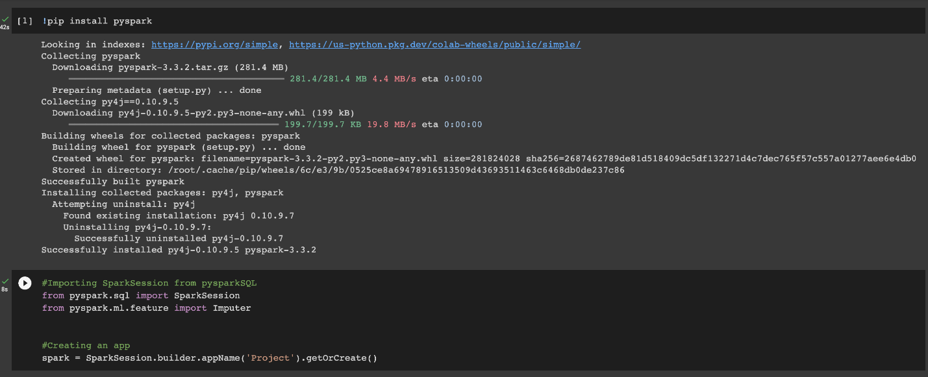Fig 7.1 - Creating spark application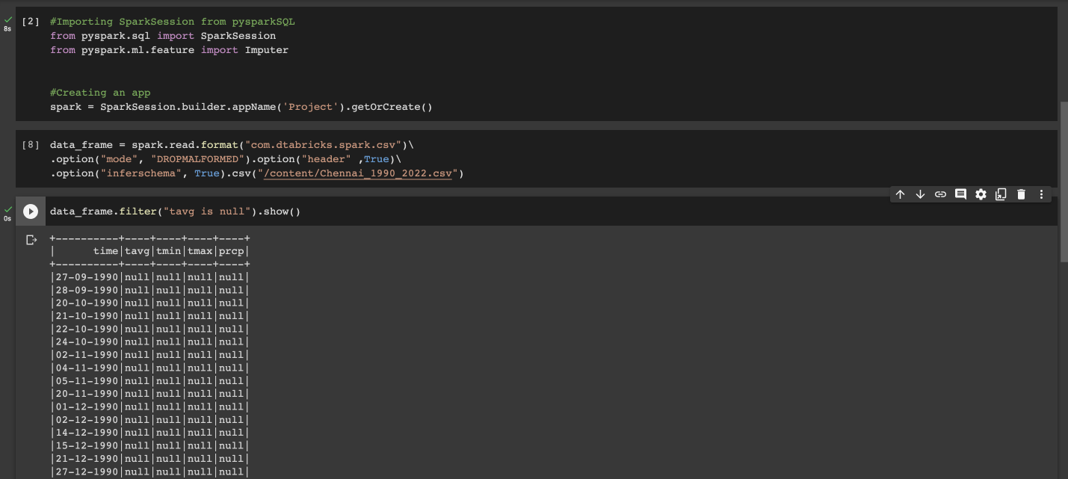Fig 7.2 -Creating a data frame from temperature data and displaying null values

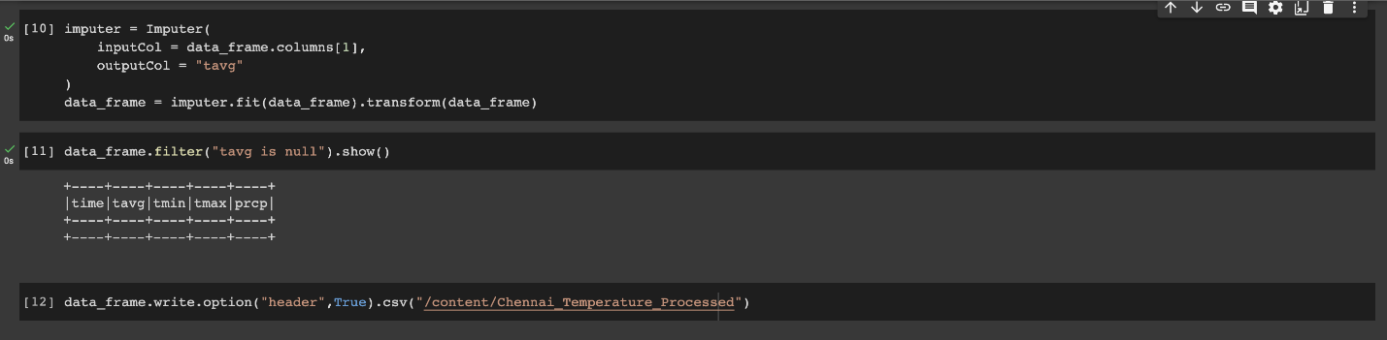Fig 7.3 - Replacing null values with mean of the column

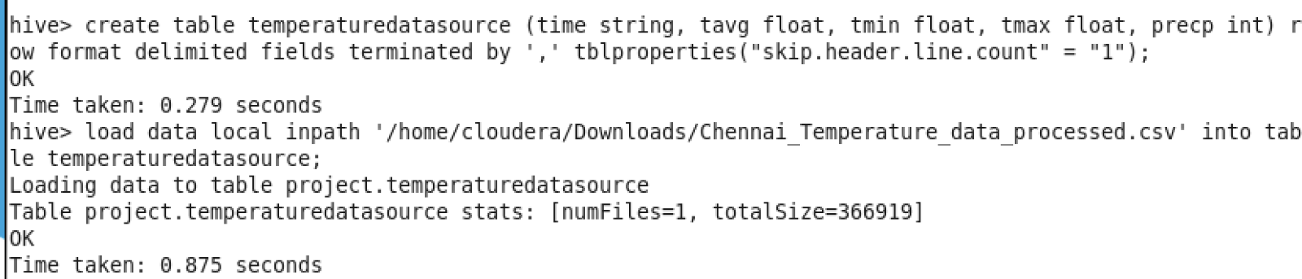Fig7.4: Creating table with pre-processed temperature data  
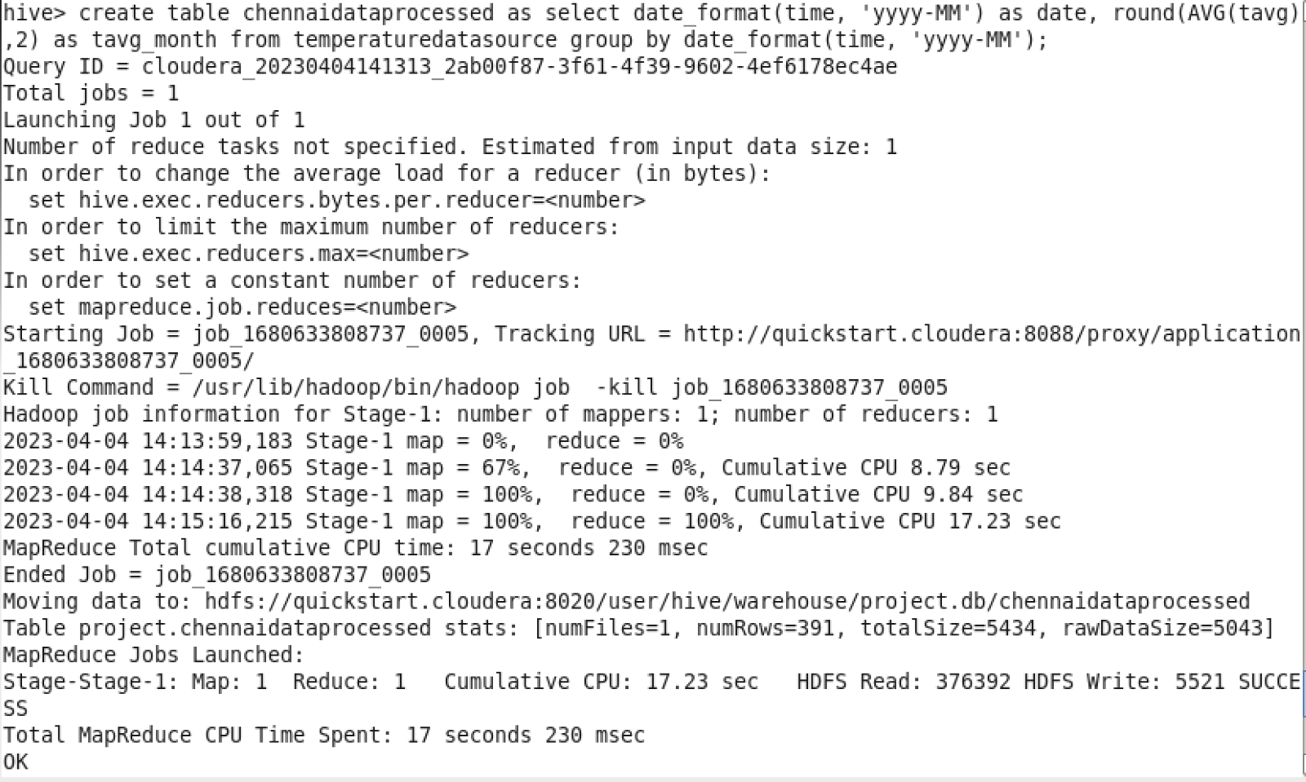Fig 7.5: Converting data from daily to monthly   
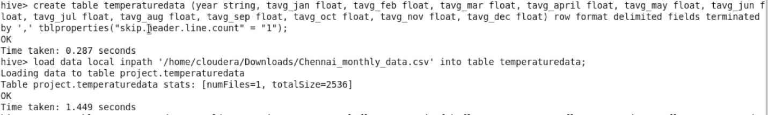Fig 7.6: Loading monthly temperature data into new table  
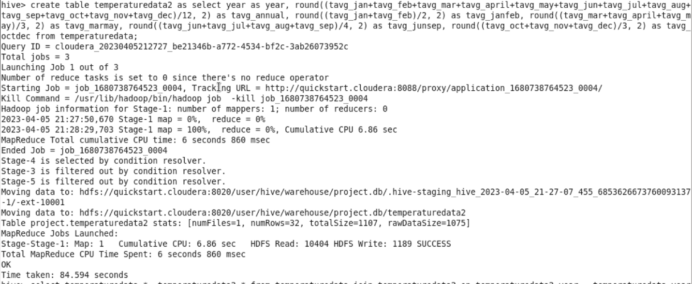Fig 7.7: creating a new table with the annual average and seasonal average  
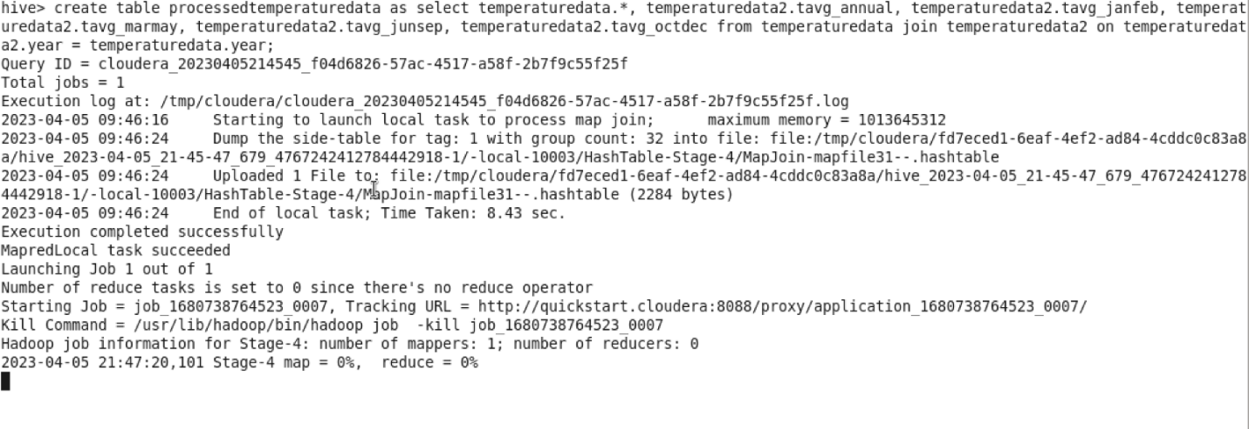Fig 7.8: Joining the monthly data table and the missing columns data table  
  
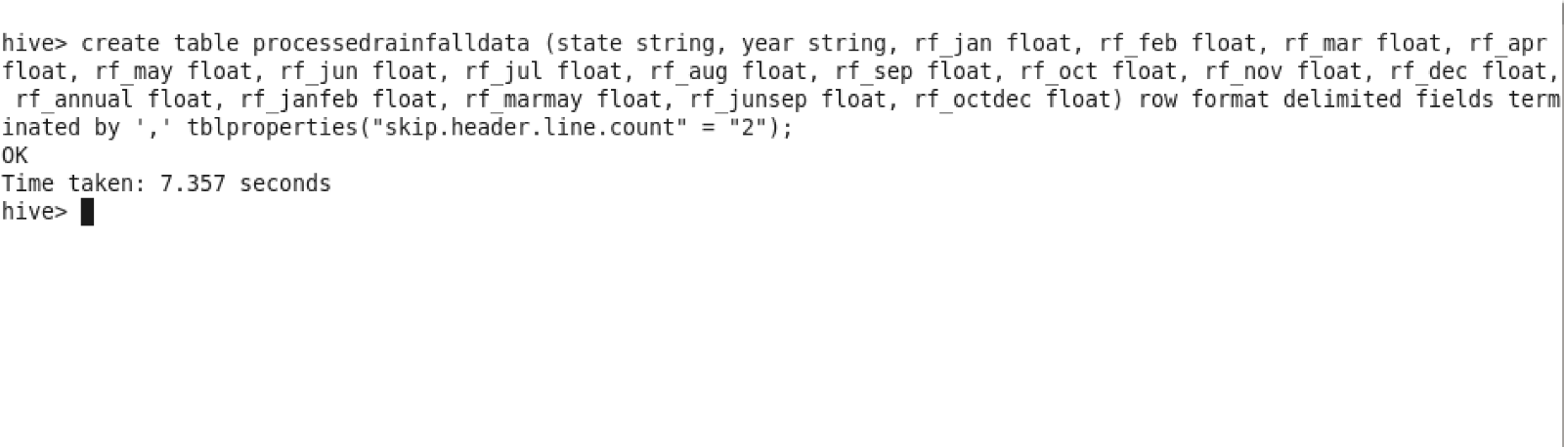Fig 7.9: Loading pre-processed rainfall data into a new table

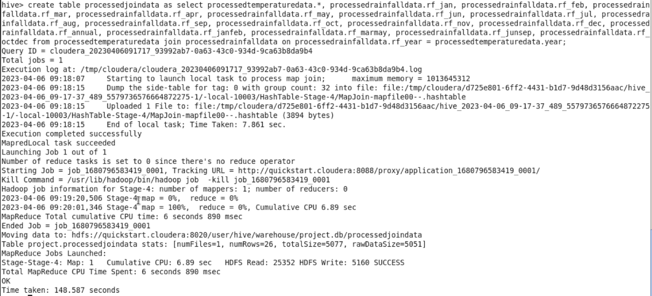Fig 7.10: Joining the processed temperature and rainfall tables to get combined data table

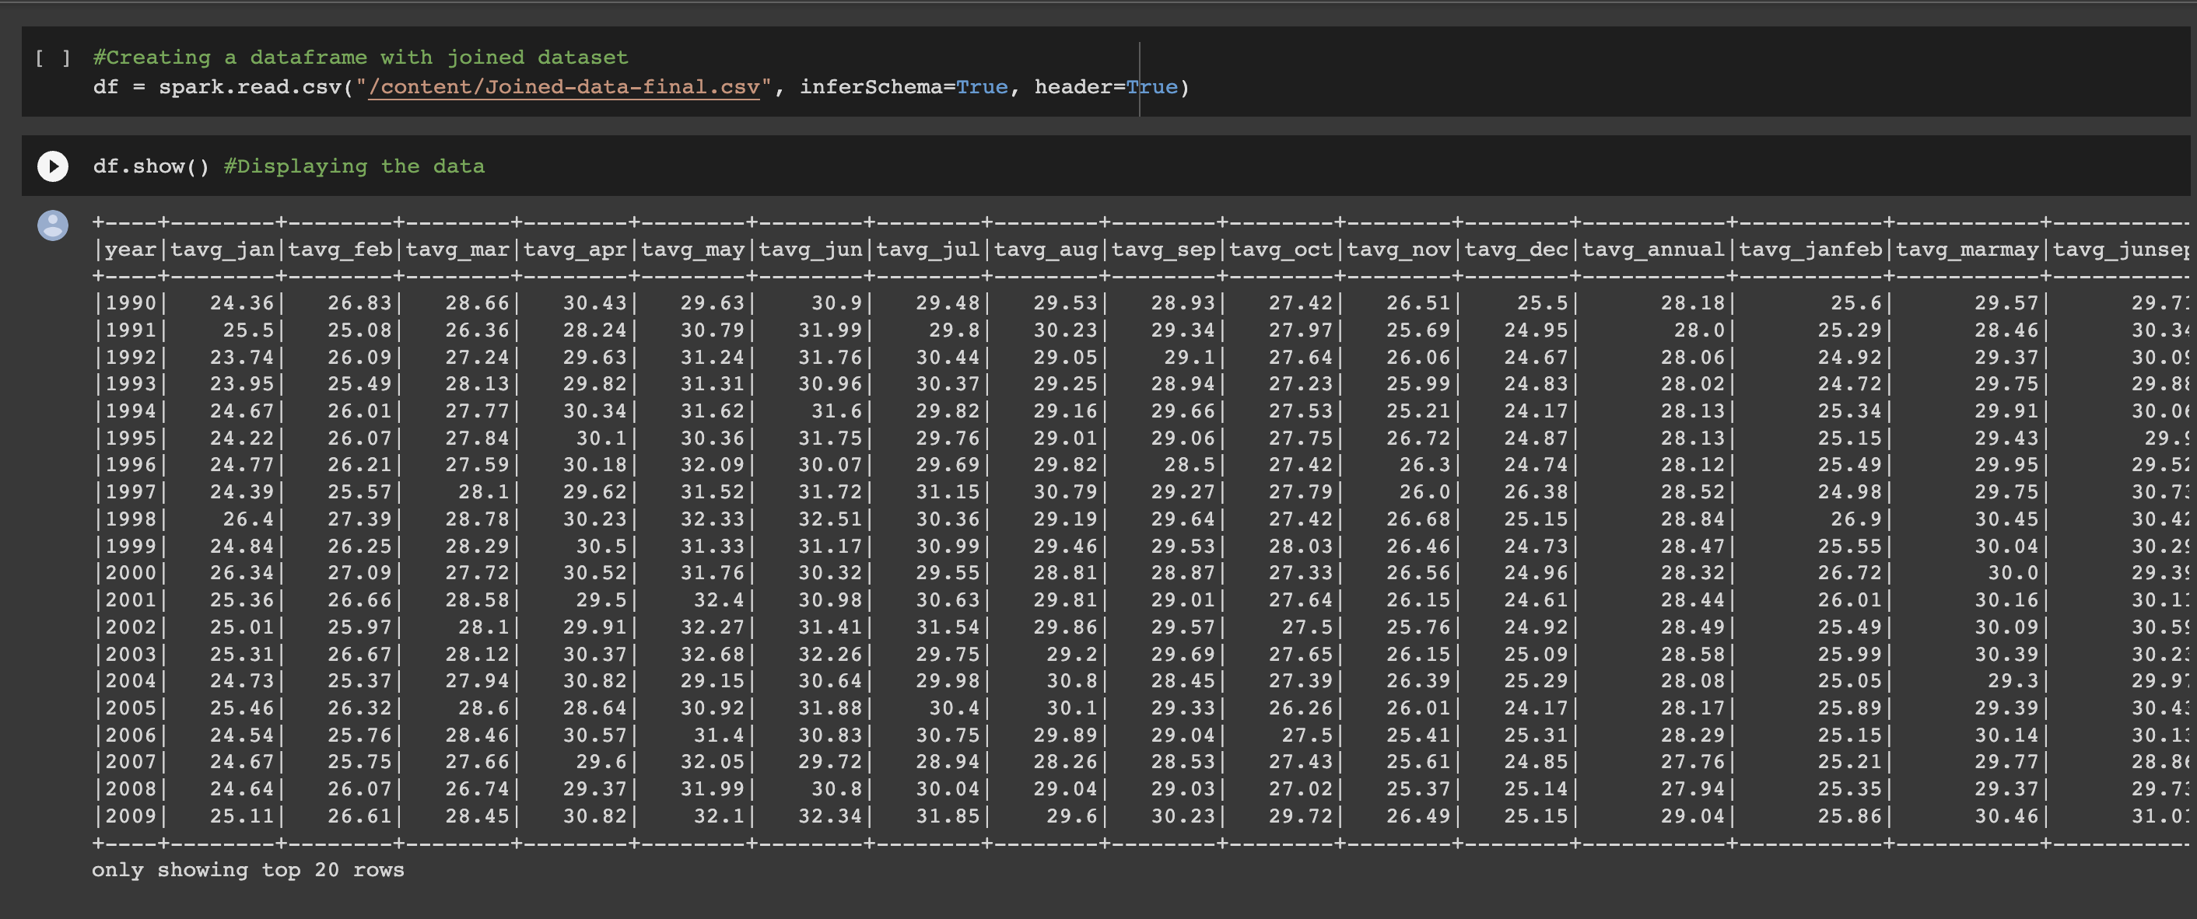Fig 7.11: Creating a data frame with the joined dataset

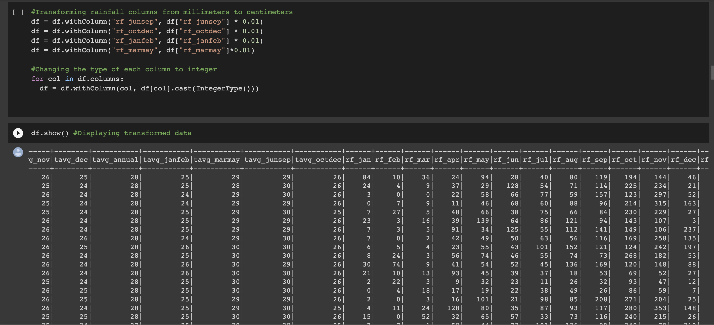Fig 7.12: Transforming the columns in data frame

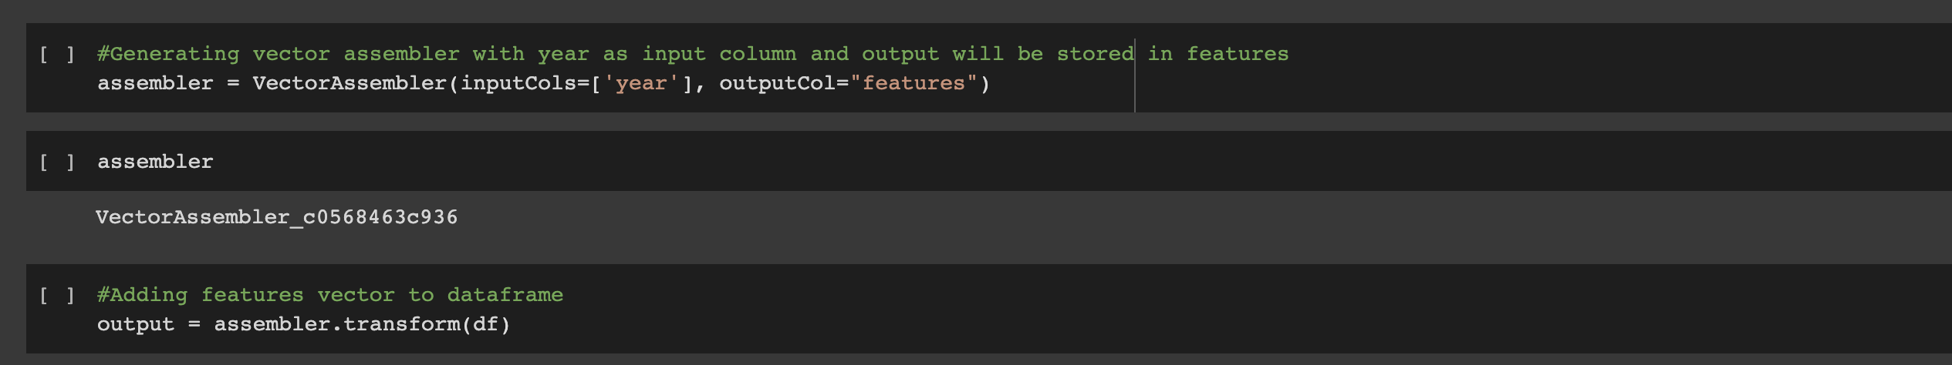Fig 7.13: Generating vector assembler with year as input column 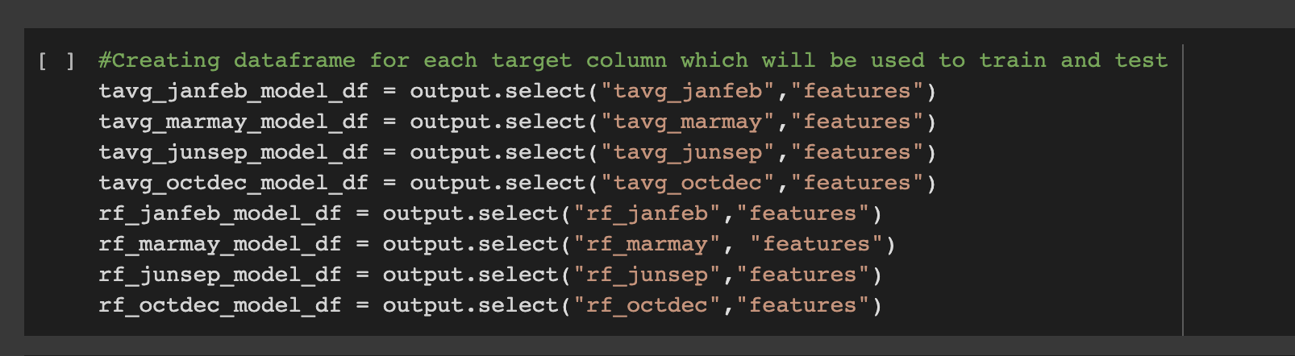Fig 7.14: creating data frames from output of vector assembler

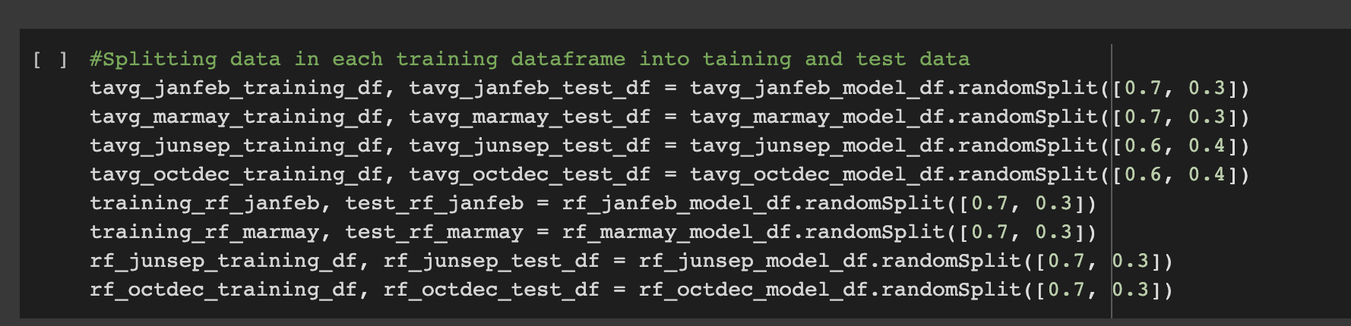Fig 7.15: Splitting data into training and test data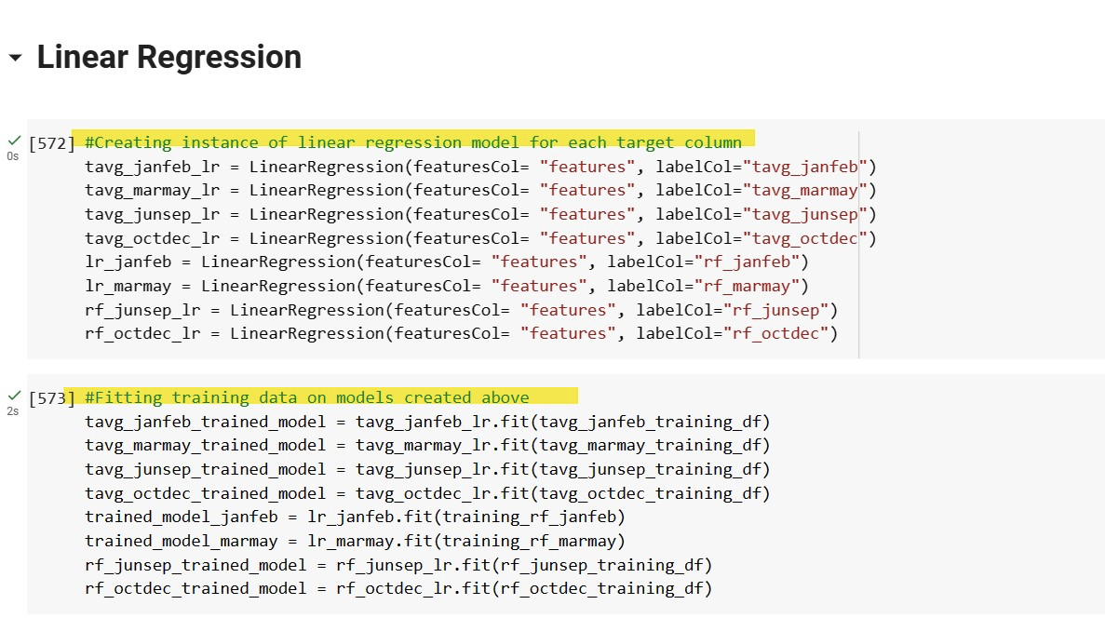Fig 7.16: Creating linear regression models and fitting them on training data

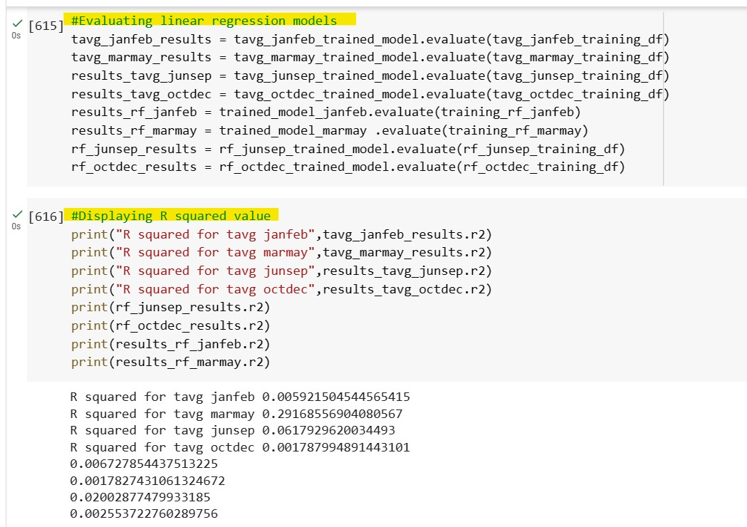

Fig 7.17: evaluating linear regression models and displaying R squared values

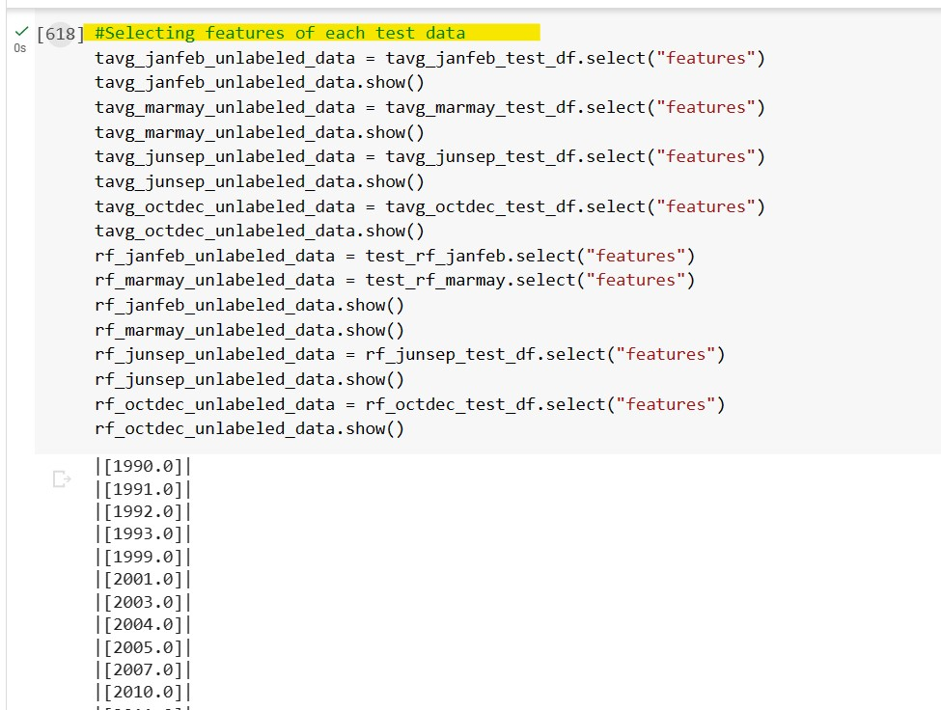

Fig 7.18: Selecting features of each test data and displaying the results

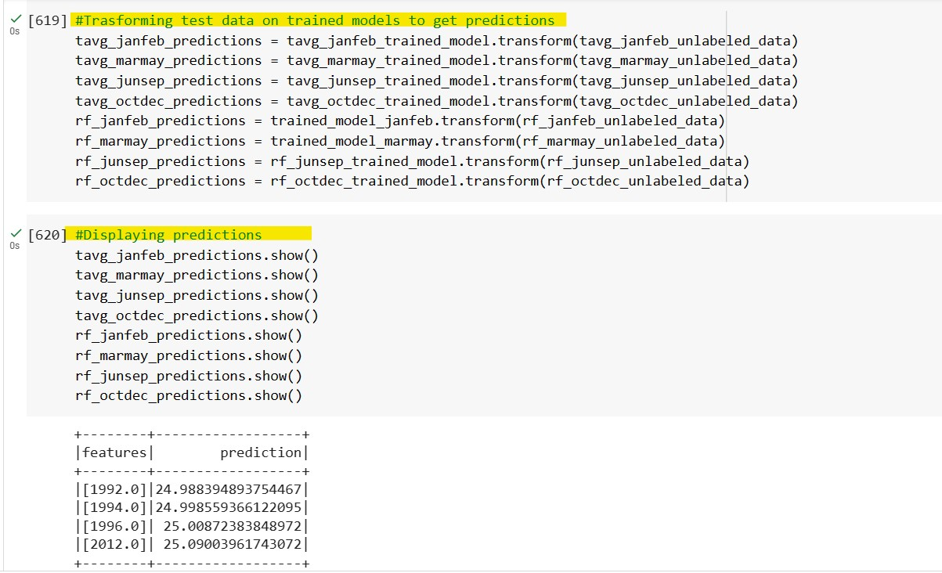

Fig 7.19: transforming test data on trained models to get predictions and displaying the resulting predictions.

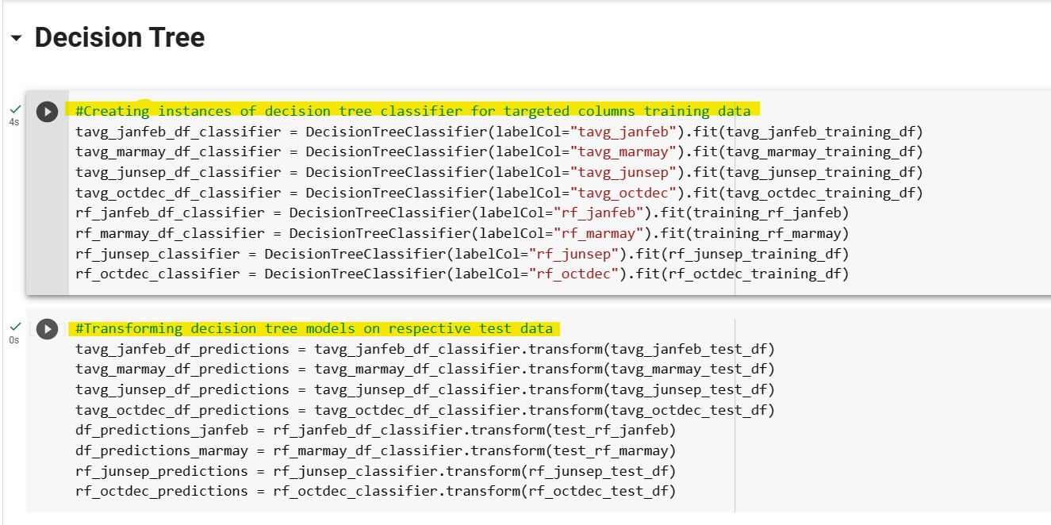

Fig 7.20: Creating instances of decision tree classifier for targeted columns training data and transforming decision tree models on respective test data

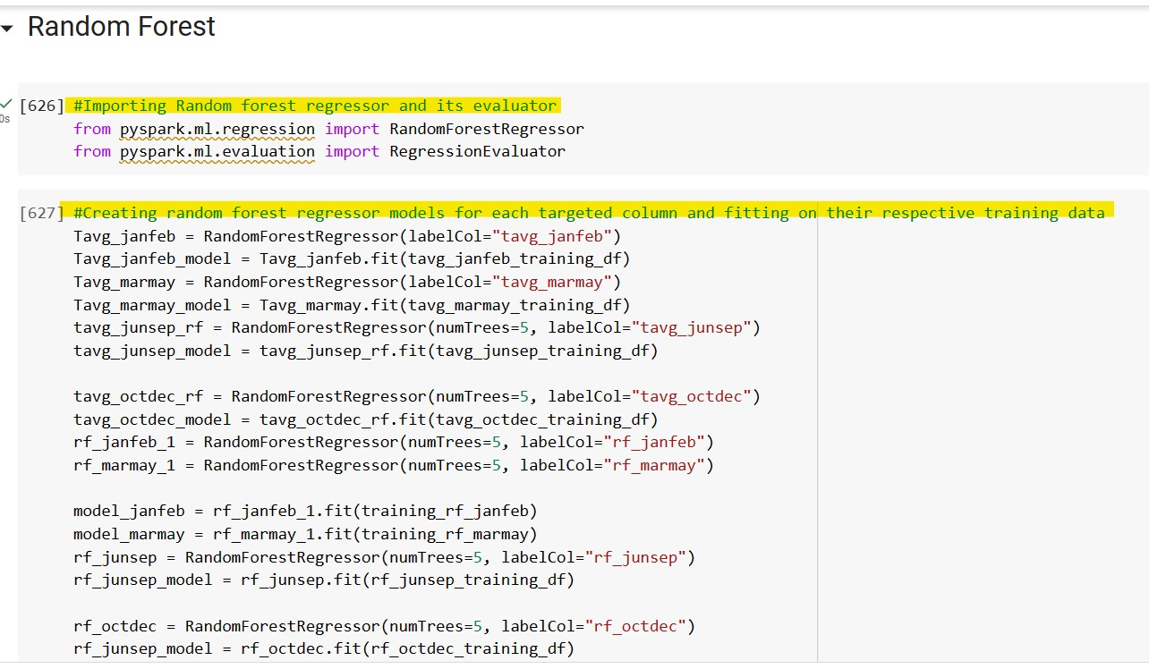

Fig 7.21: importing random forest regressor and evaluator and creating random forest regressor models for each targeted column and fitting on their respective training dataset.

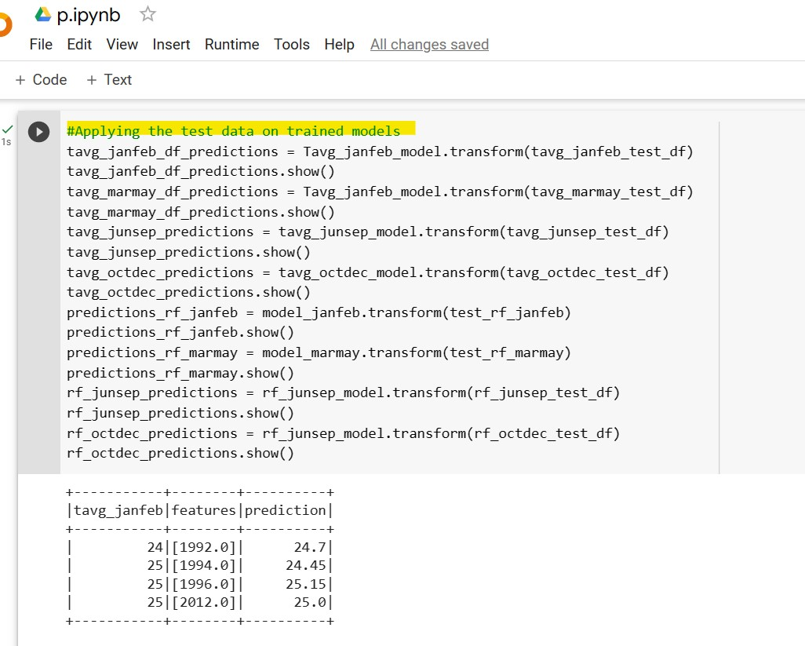

Fig 7.22: Applying the test data on trained random forest models

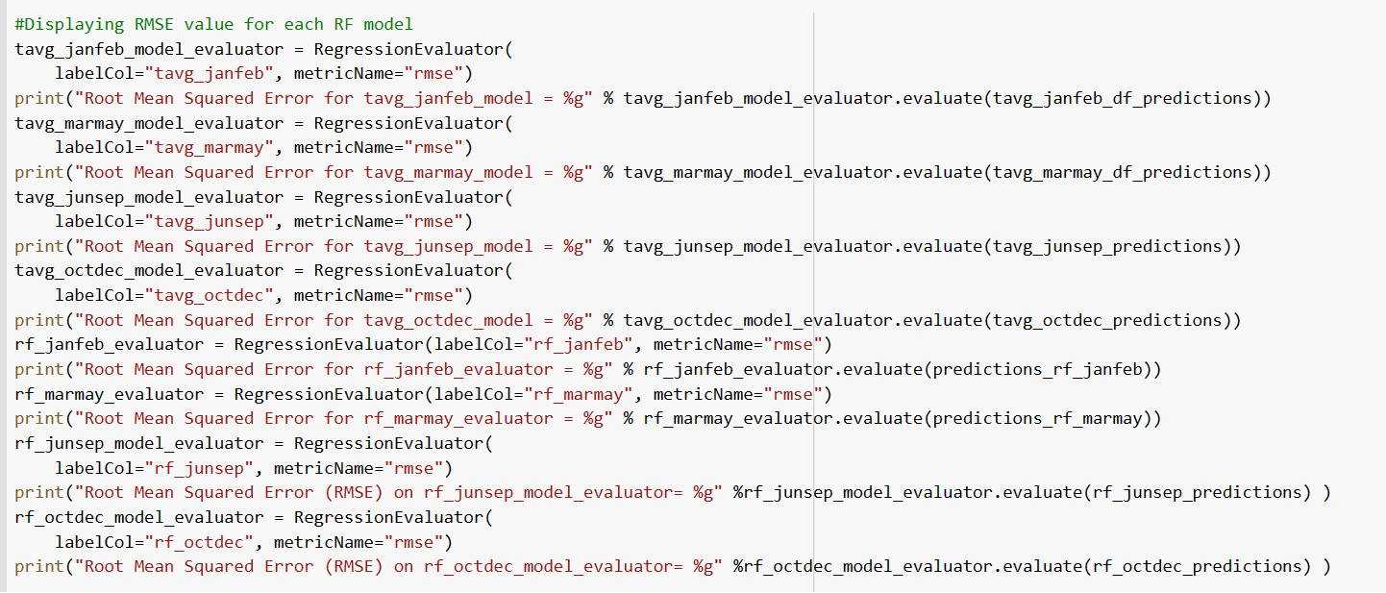

Fig 7.23: Displaying root mean squared error value for each random forest model

**8. Preliminary Results**

Visualization of rainfall data as scatter graph

From the chart in fig 8.1, we can see that the rainfall is higher in the months of October and November and is low from February to June.

Visualization of temperature data

From the chart in fig 8.2, we can see that the temperature is higher in months of march, April, May, June, August and October and was mostly higher in June.

Figs 8.3 & 8.5 are the heat maps of the monthly rainfall and temperature data, which display how the values are ranging and figs 8.4 & 8.6 are the heat maps of seasonal rainfall and temperature data

Heats maps are useful for correlating the data of rainfall and temperature and finding patterns between 2 datasets as we can see that from aug to

**Evaluation of the linear regression models**

For evaluation of the predicted results, we use R2 (R squared) value. R-squared is a goodness-of-fit metric for linear regression models. This statistic displays the percentage of the dependent variable's variance that the independent variables account for collectively. R-squared employs a simple 0-100% scale to assess the strength of the relationship between your model and the dependent variable. Here the R squared values are very less hence it is not an ideal model for our dataset.

**Evaluation of the decision tree models**

For evaluation of the predicted results, 2 metrics are used

1. Accuracy is defined as the ratio of correct predictions to total predictions made by the model.
2. Precision is defined as the ratio of true positives to the total of true positives and false positives. Precision assesses the model's ability to identify positive instances correctly.

As we can see from fig, the accuracy and precision on the test data is around 0.8 for most of the target columns so decision tree can be a choice.

**Evaluation of the random forest models**

For evaluation of the predicted results, RMSE value is considered, RMSE means Root Mean Squared Error It is used to evaluate the accuracy of the regression models. It measures the distance between the predicted value and the true value. Lower the value means better performance. Here the RMSE is low for all the target columns so Random forest regressor is ideal choice for the considered dataset

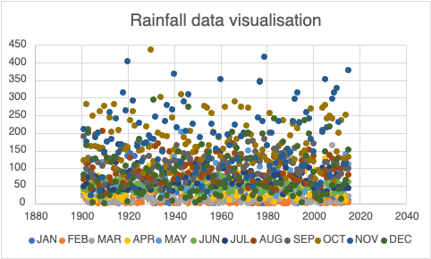Fig 8.1 - Visualization of rainfall data as scattered chart

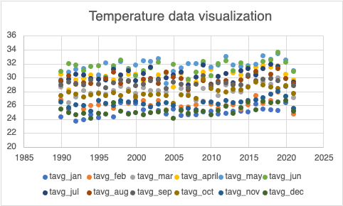Fig 8.2 - Visualization of temperature data  
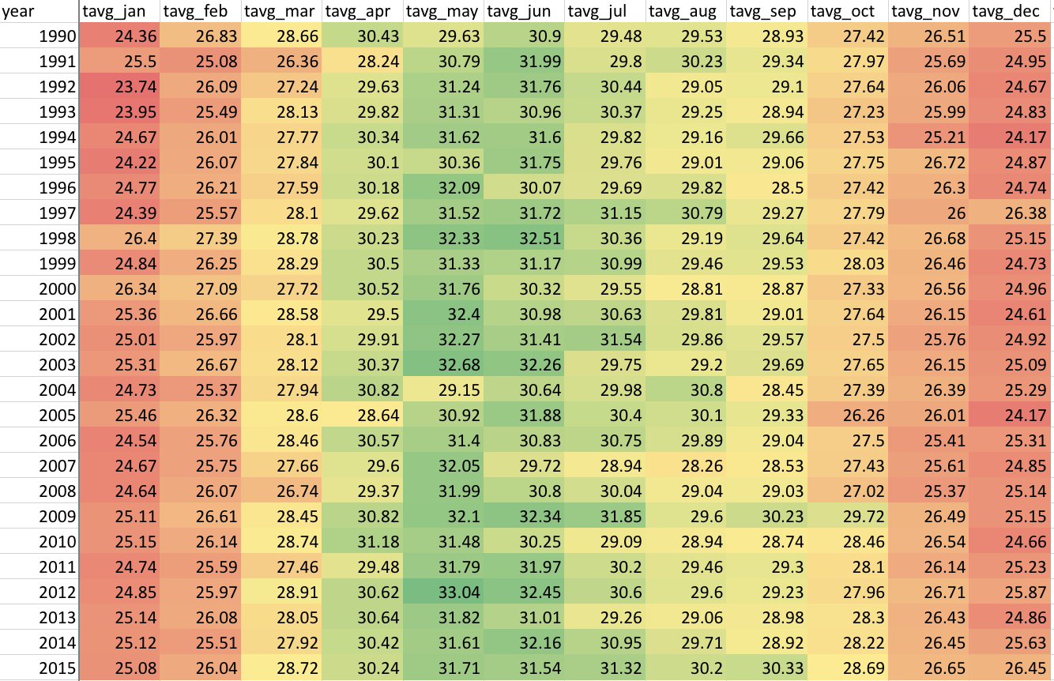Fig 8.3 - Heatmap of monthly temperature data

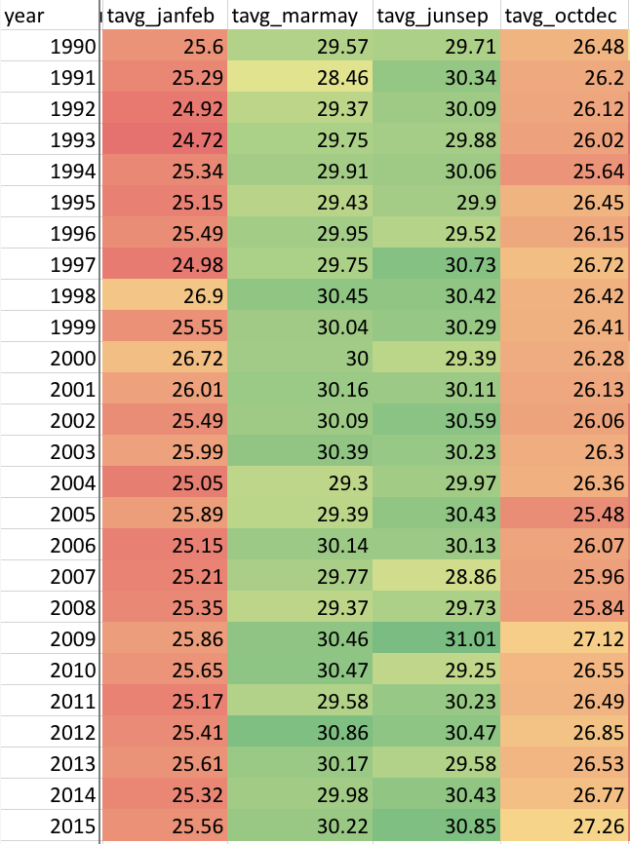

Fig 8.4 - Heatmap of seasonal temperature data  
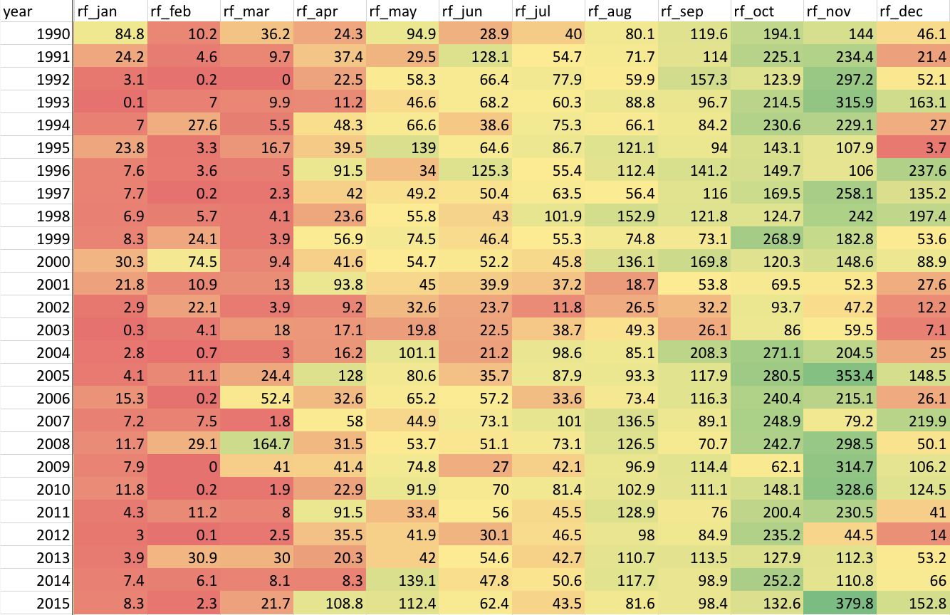Fig 8.5 - Heatmap of monthly rainfall data

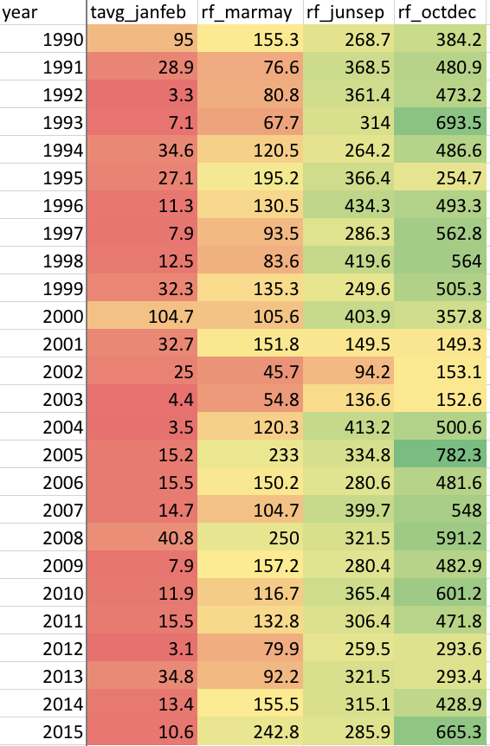

Fig 8.6 - Heatmap of seasonal rainfall data

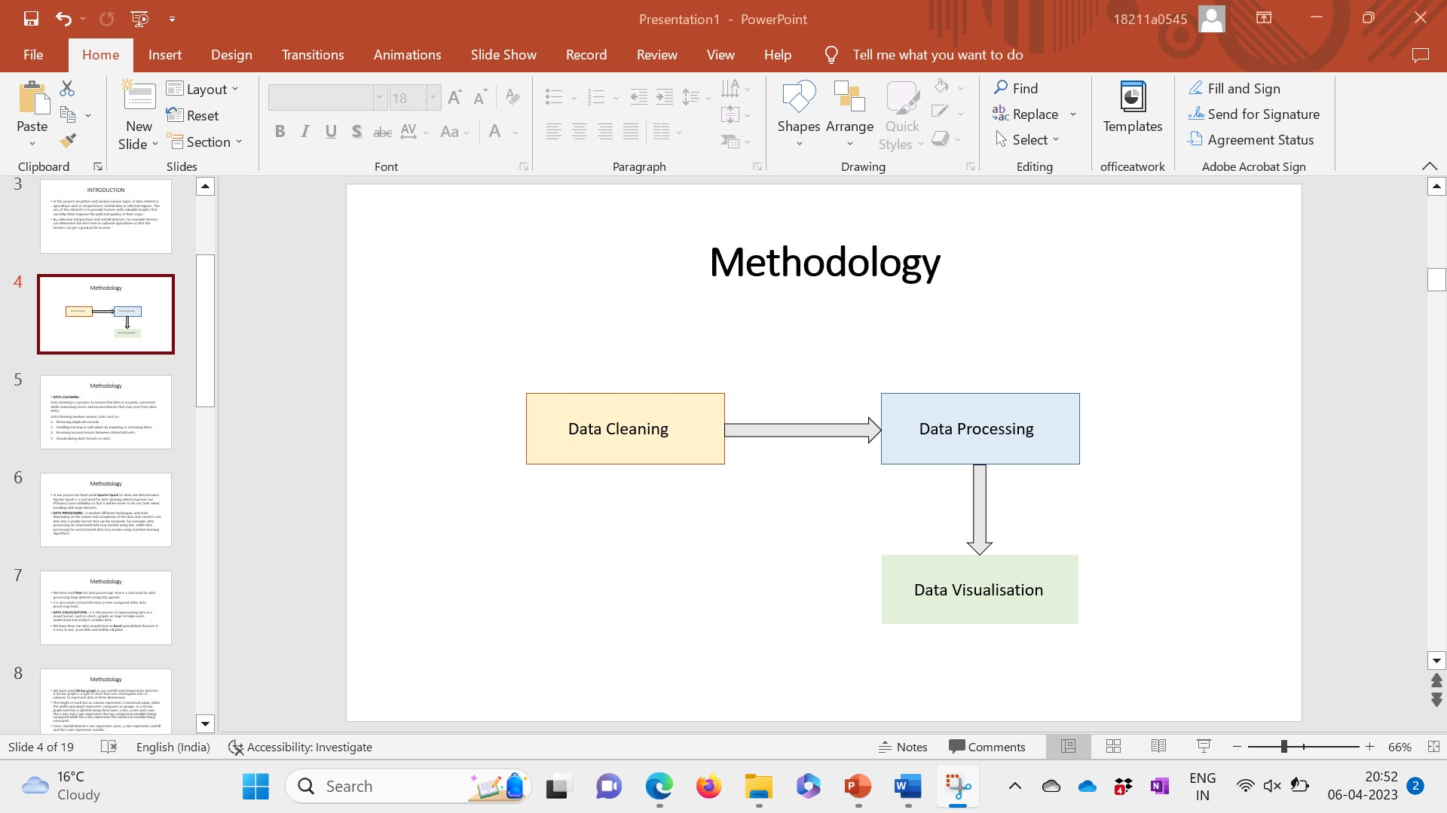

Fig 8.7 - Methodology steps

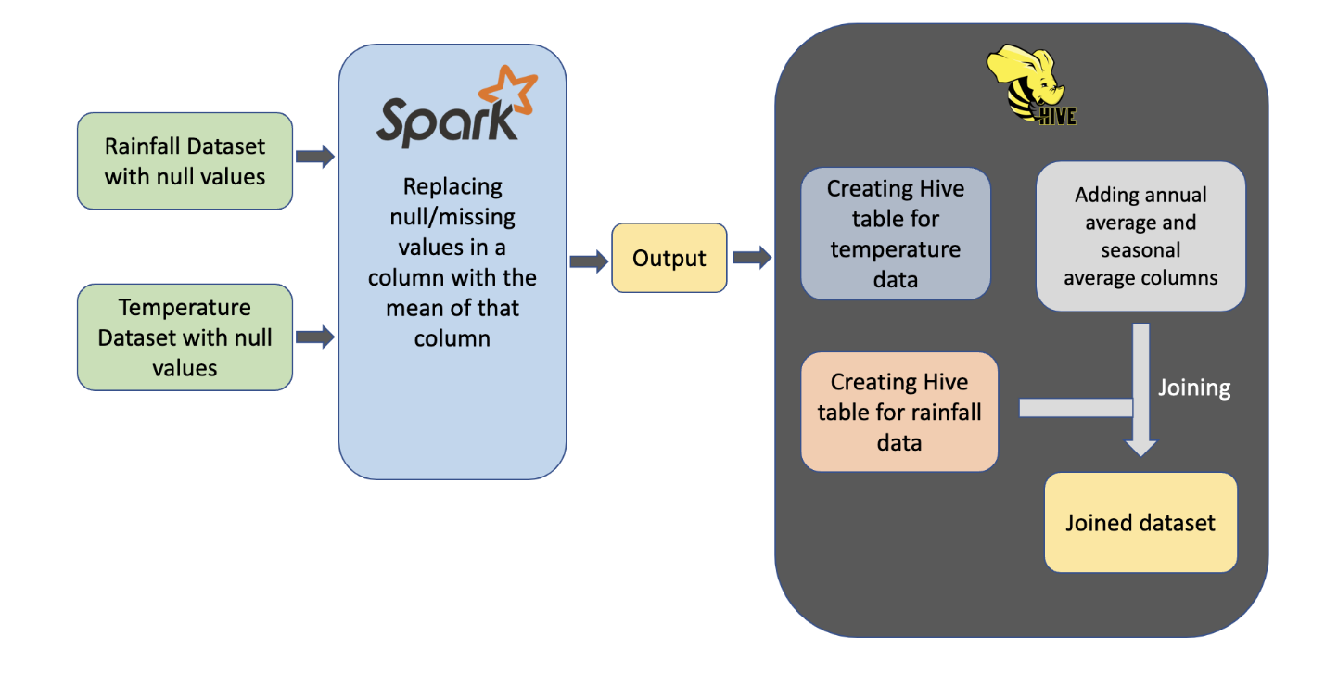

Fig 8.8 - Workflow

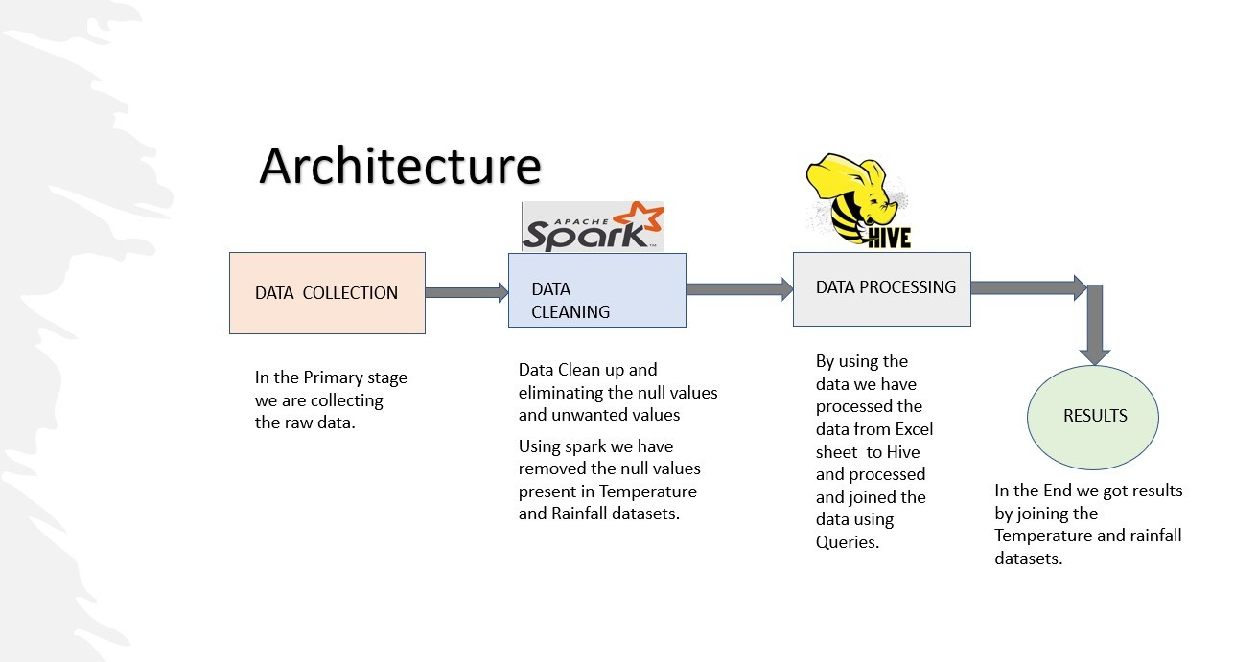Fig 8.9 - Architecture

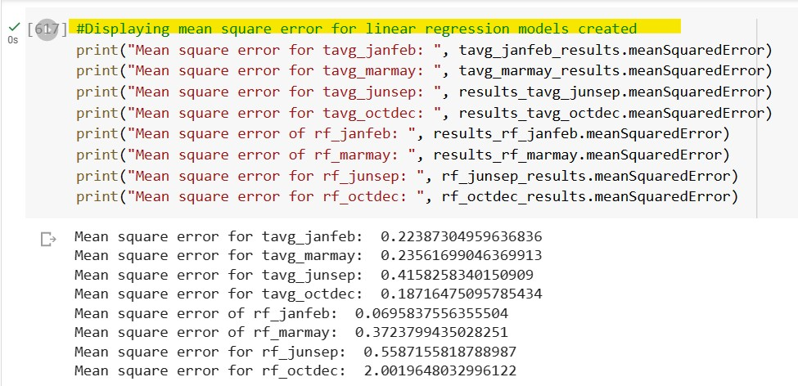

Fig 9.0: Displaying mean square error for linear regression models created for few columns

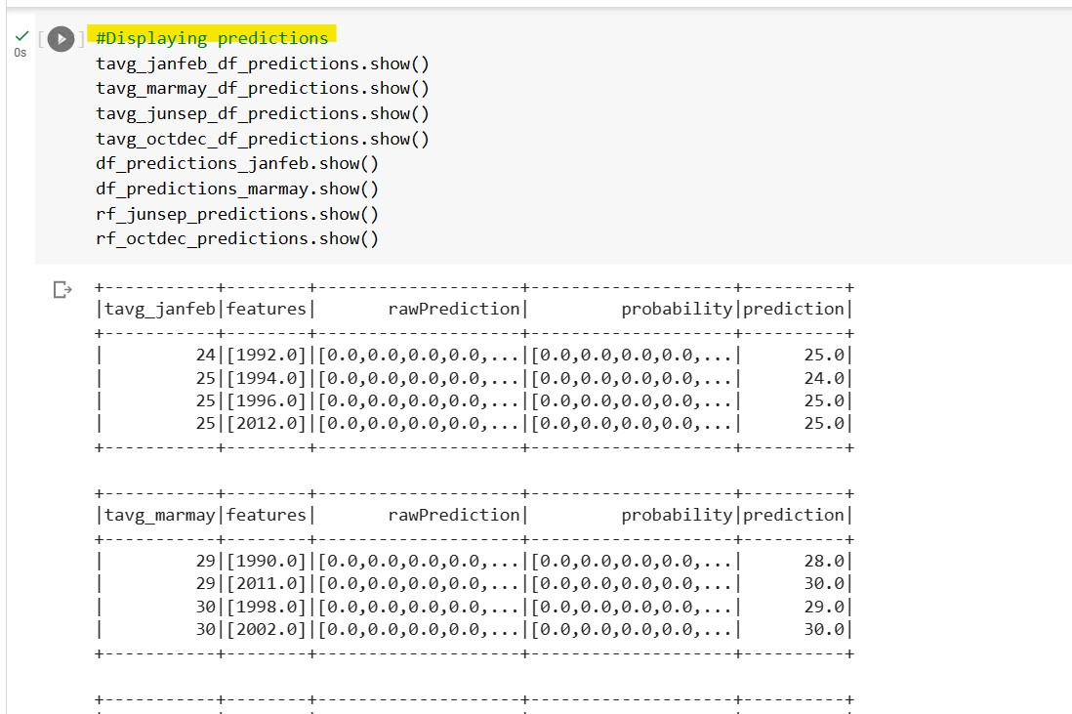

Fig 9.1: Displaying predictions for the decision tree model

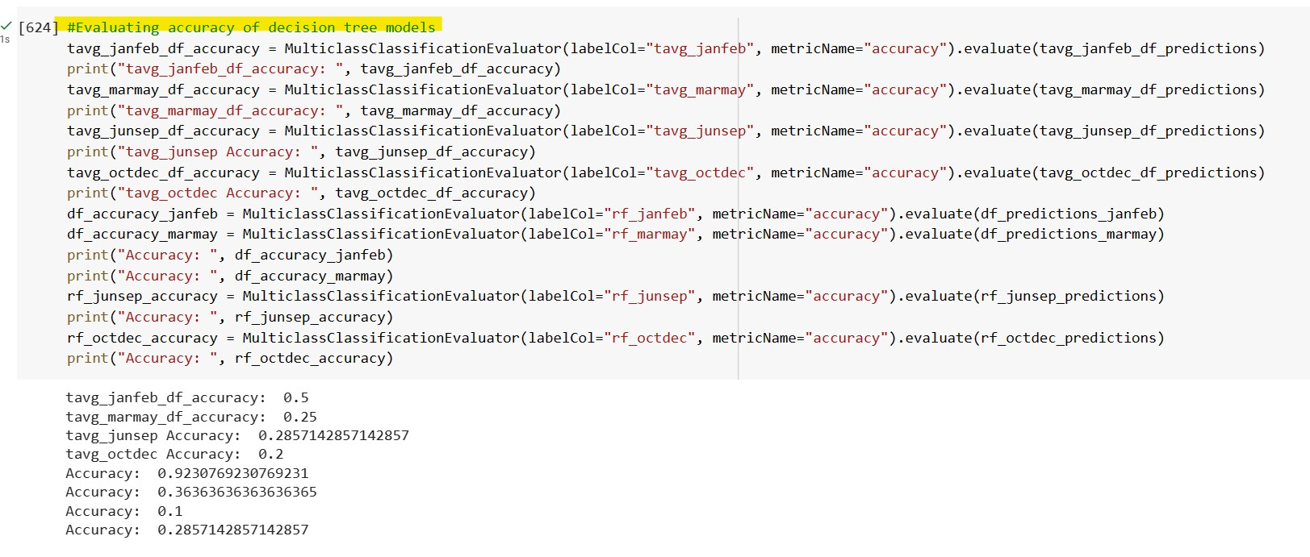

Fig 9.2: Evaluating accuracy of decision tree models and displaying its results

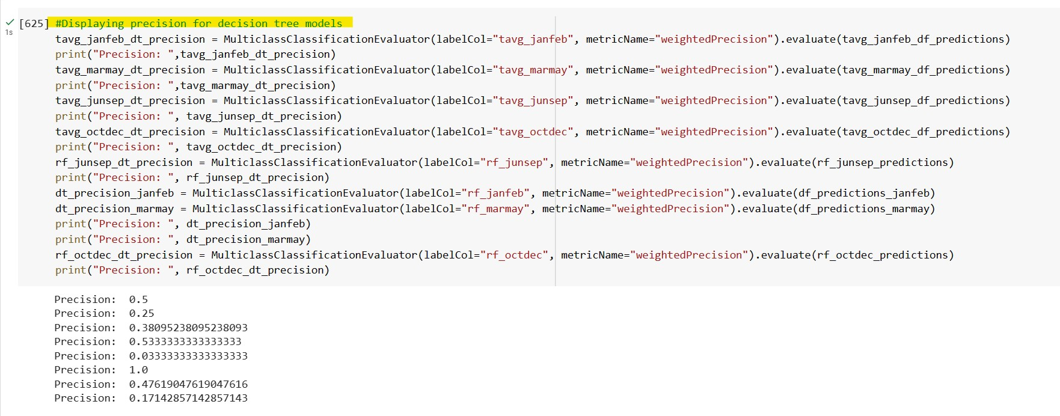

Fig 9.3: Displaying precision for decision tree models

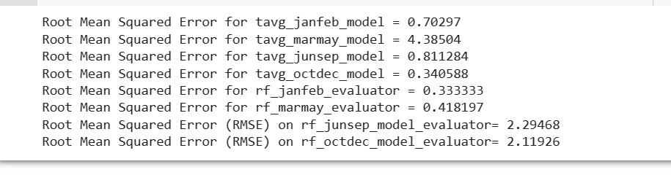

Fig 9.4: These are the results of the root mean squared error from the **fig7.23** code

**9. Project Management**

**9.1. Implementation Status Report**

Work completed

|  |  |  |
| --- | --- | --- |
| **Task** | **Description** | **Contribution** |
| Collecting datasets | Searching and gathering data related to rainfall and temperature | Surya and Anirudh |
| Analysis of Rainfall Data set | Analyzing the rainfall dataset and its features | All team members contributed equally |
| Analysis of Temperature Dataset | Analyzing the temperature dataset and its features | All team members contributed equally |
| Cleaning datasets | Replacing all the null values from the datasets with mean of the respective columns | Aditya and Mahaboob Ali |
| Processing Data sets | After cleaning the null values, we processed data by using hive. | Aditya and Mahaboob Ali |
| Merging the Rainfall and Temperature Data set values | We are merging the rainfall and temperature data sets by using the Joins. | Mahaboob Ali |

**9.2. Work to be completed**

|  |  |  |
| --- | --- | --- |
| Task | Description | Contribution |
| Build the model | During this Phase we are building the models for predicting the values. | All team members contributed equally |
| Fitting training data on models | By using the models, we are going to train the models on joined dataset | All team members contributed equally |
| Predict the Data | By the End stage, we will predict the values from trained models. | All team members contributed equally |

**10. References**

*Best Fertilizer for Wheat: Organic, NPK and Application*. (2022, February 23). Agri Farming. <https://www.agrifarming.in/best-fertilizer-for-wheat-organic-npk-and-application>

<https://www.kaggle.com/code/atharvaingle/what-crop-to-grow#About-the-data>

<https://ieeexplore.ieee.org/document/9557312>

<https://ieeexplore.ieee.org/document/9510048>

<https://ieeexplore.ieee.org/document/9864482>

<https://ieeexplore.ieee.org/document/9853054/authors#authors>

[India_Crop_Production_Analysis | Kaggle](https://www.kaggle.com/code/vasuadireddy/india-crop-production-analysis/notebook#Visualization)

[Big Data and AI Revolution in Precision Agriculture](https://ieeexplore.ieee.org/abstract/document/9505674)

<https://ieeexplore.ieee.org/document/9743001>

<https://www.kaggle.com/code/kushagranull/crop-yield-prediction/notebook>

[Effective use of Big Data in Precision Agriculture](https://ieeexplore.ieee.org/abstract/document/9396813)

<https://www.kaggle.com/datasets/rajanand/rainfall-in-india/discussion/132834>

<https://www.kaggle.com/datasets/vanvalkenberg/historicalweatherdataforindiancities>

<https://notebook.community/MingChen0919/learning-apache-spark/notebooks/ipynb/RandomForest>